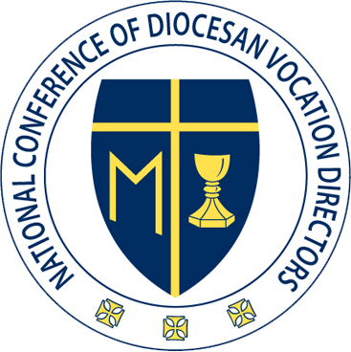

NCDVD Executive Board Meeting Minutes
June 10, 2019
Phone Conference

Fr. Jeff, Fr. Neal, Fr. Kurt, Fr. Edwin, and Rose were present.
Fr. Martin is on Retreat.

Monday, June 10th

2:00 PM EST

Fr. Jeff called the meeting to order and began with a prayer.

Rose has been trying to go live with Convention Registration however there has been glitches that have not yet been sorted out.
  - There was a hold up due to keynotes and the new structure.
  - Fr. Brett Brannen will lead the day of prayer.
  - Abbot Jeremy Driscoll is the Abbot of Mount Angels in Oregon. He will do the keynote on Thursday. He is involved in the seminary at Mount Angels, and thus, has a lot of background in vocation work and seminary formation.
Rose explained that things are moving in the right direction with the conference.

Rose has confirmed the sponsorship with the US Army, and she stated that we are started to pick up some additional sponsorships. We have a new sponsor from St. Mary’s in Baltimore.

Regional coordinators want to do more hands on projects; however, the issue is that vocation directors move around too quickly and the institutional knowledge does not get passed down.

Looking towards the 6th Edition of the PPF, many concerns have been raised regarding the Propeduetic Year. Rose has proposed making the “Propedeutic Year” the agenda item for the regional coordinators meeting.
  - Fr. Luke Ballman, from the CPLV of the USCCB, will attend the regional meeting to speak on the new Ratio.

Fr. Sean will arrive on Friday, Fr. Jeff will arrive on Thursday, Fr. Edwin will arrive on Friday, and Fr. Neal will be present for the meeting on Sunday. Fr. Kurt will double check on his availability and let Rose know.
Fr. Edwin and Fr. Neal volunteered to help facilitate the conversation following Fr. Brett Brannen’s final talk.

Fr. Jeff will email the regional coordinators with certain points, specifically noting that their meeting will be at 9:00am on Monday morning.

Rose reminded the executive board that they need to register themselves for convention, but she indicated that they should wait until everything is fully live and running properly.

Rose and Fr. Neal have been working with the Lux Labs on the promotional video for NCDVD.

The NCDVD is very grateful to Fr. Neal for his efforts in producing the video with Lux Labs.

Rose roughly explained to the executive board how the video will progress.
  - The Video will set the scene, posing the question, “What would the world be like without priests?”
  - There will be a shot of a church with a sign that says, “No Masses today.”
  - After setting that scene, there will be a scene with a priest speaking to altar servers and one server will be obviously more interested than the others.
  - Then there will be a change of scenes to the vocation office.
  - The final scene will show the face of the next young altar server to demonstrate how we proceed through the cycle with one vocation at a time.

Fr. Jeff has recruited the creative services department in his archdiocese to create the brochure for the ask.

Rose explained that Lux Labs will send a high res photo of the church doors from the opening scene that will be use for the brochure.

Rose is sending the executive board a preliminary sketch of the script, which is not final and complete, but will allow the board to get a sense of the video.

Rose had a meeting with the Bethany Center in order to try to reduce costs for future retreats because the center has continued to raise costs and they are becoming burdensome to the attending dioceses.

Rose explained that FOCUS has asked NCDVD to take over the Adoration Chapel for SLS in Phoenix.

Rose also explained that NCDVD has been asked to handle the Adoration Chapel for NCYC in Indianapolis. NCDVD had to pay membership to NCYC and Rose had to be interviewed to prove that NCDVD was worthy to be part of the NCYC membership.

Fr. Kurt ended in prayer.

