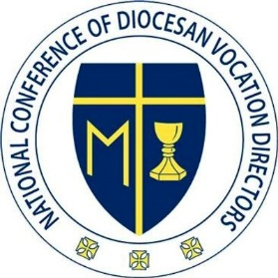
NCDVD Executive Board Meeting
March 29, 2023
Held on Zoom

Board Members present - Fr. Brian Buettner, Fr. Chuck Dornquast, Fr. Neal Hock, Fr. Eric Augenstein, Fr. Michael Pratt, Fr. Gino de la Rama

Excused - Rose Sullivan, Cathryn Sullivan

Meeting was called to order at 3:05 pm by Fr. Chuck Dornquast. Opening prayer led by Fr. Gino.

- Fr. Chuck presented to the board the history of conversations between NCDVD and Tim Watkins of Messenger Eagle Communications to seek approval for an expenditure of $300,000 from NCDVD funds to partner with Messenger Eagle in creating marketing content for member dioceses and allowing individual dioceses to partner directly with Messenger Eagle for an additional cost to create AI content specific for their diocese.
  - Board members asked clarifying questions.
  - Fr. Gino made a motion to decline the offer from Messenger Eagle to enter into a partnership with them at the present time, to be potentially revisited in a year or two. Fr. Eric seconded the motion. The motion passed unanimously.

- Fr. Chuck reported on the recent gift of $150,000 NCDVD has received from Bob Flanagan and indicated his desire for ongoing support to assist our development efforts.

- The Board discussed the plan to create a series of videos for new vocation directors in preparation for their participation in August's Vocare Institute. In the interest of time and resources, the consensus was reached to do audio-only podcast-style recordings this year with the goal to expand to video next year. Fr. Chuck plans to devote time soon to identifying presenters and deadlines. An additional meeting will be held to work out details.

Fr. Eric led a closing prayer.

The meeting was adjourned at 4:07 pm.

Respectfully submitted,
Fr. Eric Augenstein
Board Secretary

