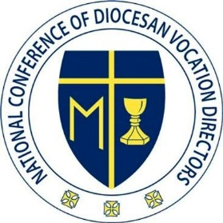
NCDVD Executive Board Meeting
April 20, 2023
Held on Zoom

Board Members present - Fr. Brian Buettner, Fr. Chuck Dornquast, Fr. Neal Hock, Fr. Eric Augenstein, Fr. Michael Pratt, Fr. Gino de la Rama, Rose Sullivan, Cathryn Sullivan

Meeting was called to order at 3:05 pm by Fr. Brian Buettner, who led an opening prayer.

- Rose gave an update on a meeting with Miguel Naranjo from CLINIC on changes to immigration process for R1 visas and Green Cards. With board approval, Rose and Miguel will put plans in place for a webinar on this topic over the coming weeks.
- The board discussed plans for the Vocare Institute Toolbox, a series of podcasts or videos created by board members and sent to new vocations personnel prior to the in-person Institute. A proposal was made to not send the link to the toolbox out until after new men register for the in-person Institute. It was determined to present the Toolbox as videos made through Zoom recordings, saved to the presenter’s own computer, then uploaded to the NCDVD Google Drive for editing by Cathryn: https://drive.google.com/drive/folders/143KRYxE9jlzzo5A1Vet4HLYfi3LJRrge. In general, each video would be less than 30 minutes; the psychological evaluation video may be longer. See full break-down attached. Videos are to be recorded and uploaded by June 1, 2023.
- Plans for the in-person Vocare Institute were discussed.
  - The proposal was made to assign participants to small groups/cohorts, each with a member of the Executive Board, that they will stay with throughout the weekend, perhaps organized by region or adjoining regions. Rose and Shannon will make the assignments after registrations come in.
  - On Sunday, formal programming will be limited to the morning. After the midday Mass, an informal BBQ will be held, followed by free time through the rest of the afternoon.
  - Fr. Pratt will be sending a more detailed document outlining proposed content for the sessions.
  - Rose will be working on a detailed schedule based on the conversations held.
- For the full Convention, Rose will begin working on a detailed schedule of timing and workshops.

Fr. Mike Pratt led a closing prayer. The meeting was adjourned at 4:42 pm.

Respectfully submitted,
Fr. Eric Augenstein
Board Secretary
The Vocare Institute: Toolbox

Purpose: The toolbox for the Vocare Institute consists of the foundational elements, or tools, which each vocation’s director must be familiar with. The toolbox is an effort of the National Conference of Diocesan Vocations Directors (NCDVD) to provide for its membership and to serve the vocation ministry of the Catholic Church. This content is intended to serve the priest, deacon, religious or administrative assistant who has newly been assigned to vocations ministry. While designed to be an essential part of the Vocare Institute for new vocation’s directors, the content of The Toolbox is able to stand alone. The content will consist of video tutorials and PDF’s.

Format: The toolbox will consist of tutorial videos which explain the essential elements of vocation ministry. Several of the tools The videos will be 15-20 minutes in length and offered by individuals with a depth of experience in that field. When helpful the tutorial videos will be accompanied by PDF documents.

The Process: After watching the welcome/introductory video, individuals will be able to proceed through the tools at their own pace. Each tool may have several tutorial videos.

The Means: Video hosts would sign into their personal zoom account and record meeting to their own computer. Following the recording they would upload to the NCDVD shared drive: https://drive.google.com/drive/folders/143KRYxE9jlzzo5A1Vet4HLYfi3LJRrge

Timeline: Videos should be submitted by June 1, 2023

The Tools:

- What’s in the Toolbox video Fr. Brian Buettner (assisted by Rose)
  - Welcome to the tutorials
  - What is NCDVD and who are the board and members
    - Who is Rose Sullivan
  - How to use this toolbox
- New Relationships Fr. Chuck
  - How to work with our Bishop, Diocesan Leadership, staff
  - Your new relationship with your predecessor and brother priests
  - Relationship to apostolates
- Vocation and Discernment Fr. Pratt
  - What is a vocation? How does it fit into baptismal call?
  - What is discernment? How do you discern with others?
- Assessment of your situation Fr. McCandless
  - Video 1:
    - Importance of assessments, how to assess and creating an assessment
    - Brother priest, programs, parishes
  - Video 2:
    - Establishing an annual assessment of your office
- Administrating your office and knowing your calendar Fr. Eric A.
  - Basics of your office
    - Financial resources of the office - where does the money come from?
    - Resources available - diocese, staff, NCDVD
    - Programs/systems for tracking
  - Know your calendar
    - What is already happening in your office, what events are coming up?
  - Know your seminarians
    - Read their files
- Budget and Finance Fr. Neal Hock
  - How you spend your money
    - Seminarian stipends
    - Insurance
    - Tuition
    - Office expenses
- PPF 6 Fr. Jorge Torres
  - What is the history of PPF 6, what is the new breakdown?
    - Propaeduetic, Discipleship, configuration, Synthesis
- Psych Evals St. Luke Institute provides
  - Content couple potentially cover everything up unto “Case Studies.”
  - Video 1:Team, Documents, Language, requirements, confidentiality
  - Video 2:
- Working with Parents Rose Sullivan and Fr. Neal
  - Fr. Neal speaks from perspective of Vocations Director
  - Rose speaks from perspective of a parent
- Life balance; assess full-time and part-time Gino - Full Time; Buettner - Multiple
  - Full Time:
  - Part Time:
  - -Having a specific apostolate, not vocation work Ex. Advent Penance service

—-------------------------

Before recording:
- Open General settings
- Click “Recording”
- Ensure the following are checked:
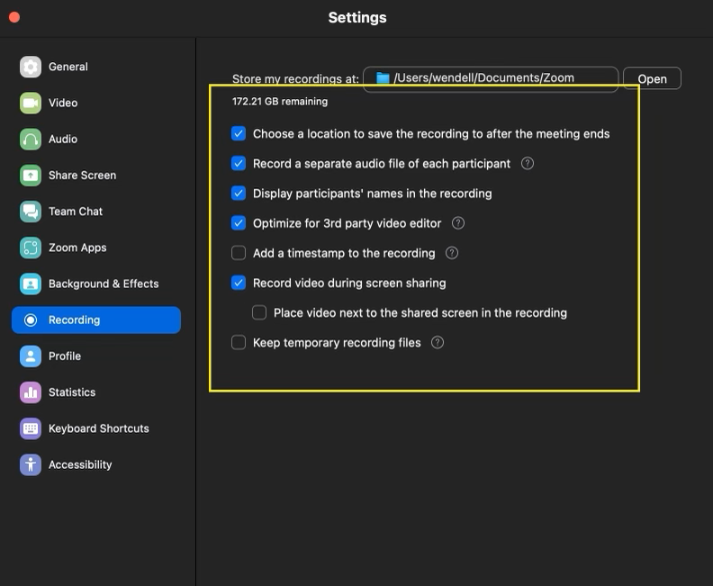

To run zoom call:
- Open zoom
- Starting meeting
- Copy link and send via email (or text, using email may have delays)
- Start meeting
- Let users in
- Begin Record
- End recording (whether ending just recording or rending recording and meeting simultaneously)

To find file/move file:
- Click “iCloud Drive”
- Documents
- Zoom
- Check file that that matches date meeting was held
OR
When video pops up in files, immediately drag file into “Desktop” folder

To share files:
Right click and select mail
OR
Create new draft and attach file(s) to draft before

